Brady Heinz 8.2 Assignment 2/22/2026
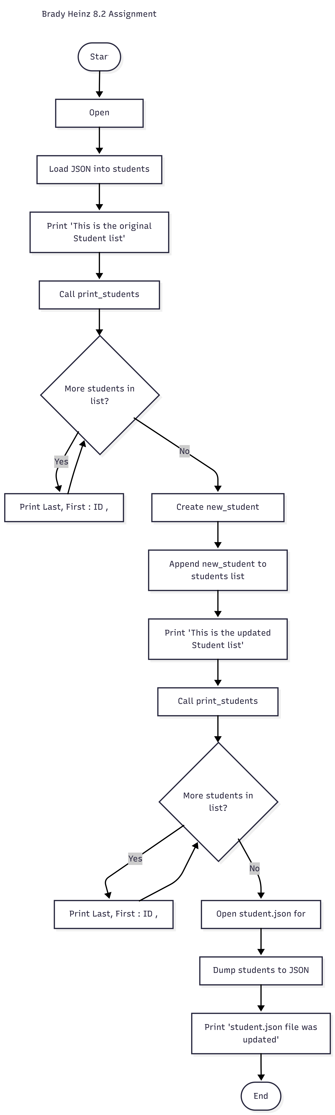

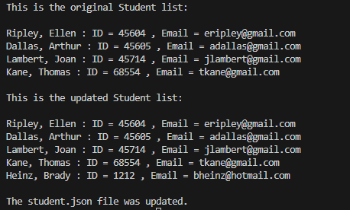

I never received a notification about the file being modified, but it was updating the .json file

[
{
"F_Name": "Ellen",
"L_Name": "Ripley",
"Student_ID": 45604,
"Email": "eripley@gmail.com"
},
{
"F_Name": "Arthur",
"L_Name": "Dallas",
"Student_ID": 45605,
"Email": "adallas@gmail.com"
},
{
"F_Name": "Joan",
"L_Name": "Lambert",
"Student_ID": 45714,
"Email": "jlambert@gmail.com"
},
{
"F_Name": "Thomas",
"L_Name": "Kane",
"Student_ID": 68554,
"Email": "tkane@gmail.com"
},
{
"F_Name": "Brady",
"L_Name": "Heinz",
"Student_ID": 1212,
"Email": "bheinz@hotmail.com"
}
]

